Imagery
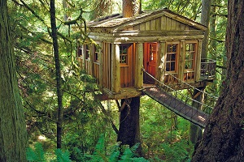

Write Your Own Imagery. Imagine being in this scene. What senses could you imagine being sparked? Write a stanza using imagery for this image.
In your most descriptive words, how could you describe this scene?
Try writing down all the senses first (sight, sound, etc.), and then fill in the ideas you come up with next to them.

