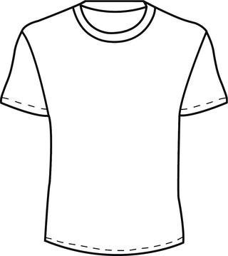

Instructions:

* Design an **original** t-shirt using a slogan or a tongue-twister to describe yourself.
* The slogan must include at least three alliterative words.
* Your design should be creative and colorful.

* Your assignment will be graded using the attached rubric.